# Installing Sample Data for the Dynamics 365 Higher Education Accelerator

Prerequisites

* A Dynamics 365 Instance with the Higher Education Accelerator installed from AppSource
* The Higher Education Sample Data [file](https://github.com/Microsoft/Dynamics-365-Industry-Accelerators/tree/master/edu/accelerator)
  + EducationAccelerator.DataPackage_1_0_0_6
* NuGet
  + Download **nuget.exe** from <https://www.nuget.org/downloads>, and save it to your computer, say **c:\**. (This location is used in Step 2.a. so if you save this somewhere else, take note and update the sample path provided accordingly)

## Use Package Deployer tool to deploy packages

1. Obtain the package to be deployed from GitHub using the link above. The package will contain:
   1. PkgFolder: This folder contains the solutions, import configuration, and the contents for your package.
   2. EducationAccelerator.Datapackage.dll: The assembly contains the code for your package.
2. Obtain the Package Deployer tool. The Package Deployer tool is available as a [NuGet package](https://go.microsoft.com/fwlink/?linkid=859205).
   1. Then run the following command at the command prompt to extract the package contents to a folder, say **PD**, on your computer:  
      c:\nuget install Microsoft.CrmSdk.XrmTooling.PackageDeployment.Wpf -O c:\PD
      1. Note: This location may be different based on where you have the nuget.exe file saved
3. After you have extracted the Package Deployer tool, browse to the [ExtractedLocation]\tools folder to find the **PackageDeployer.exe** file.
4. Copy the PkgFfolder and EducationAccelerator.Datapackage.dll files from the Sample file download to the [ExtractedLocation]\tools folder (same folder as the PackageDeployer.exe).
5. After the files are copied, run the tool by double-clicking the PackageDeployer.exe file in the [ExtractedLocation]\tools folder.
   1. If you get an error saying that no import package can be found, right click on EducationAccelerator.Datapackage.dll and select Properties. Select the “Unblock” option and then Ok. Retry running the PackageDeployer.exe

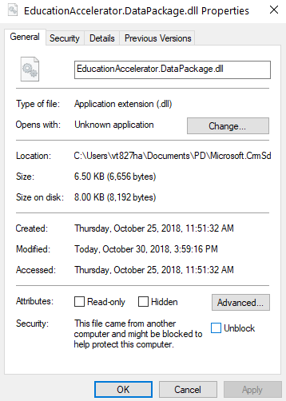

1. Click **Continue** on the main screen of the tool.
2. In the **Connect to Microsoft Dynamics 365** screen, provide authentication details to connect to your Dynamics 365 server where you want to deploy the package. Click **Login**.
3. You will be presented with a Welcome screen. Select **Next**.

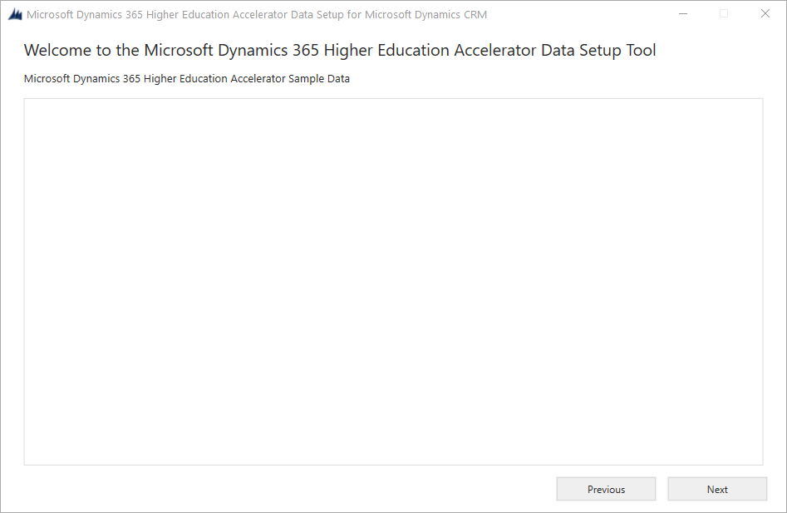

1. Review the Details of the instance where the Sample Data will be imported and select Next.

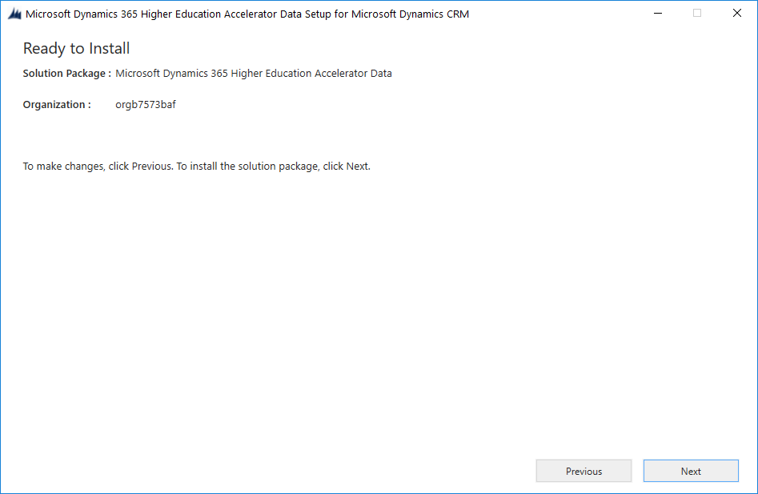

1. The tool will validate that all components are available and when all green checks appear, select Next.

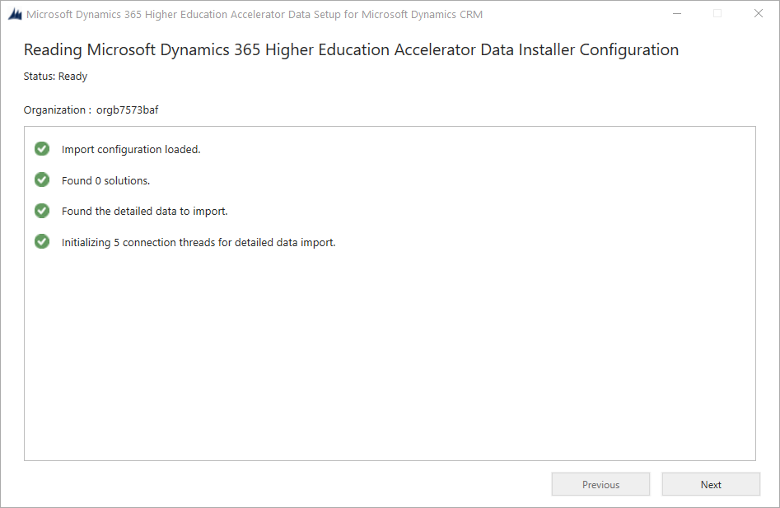

1. You can monitor the import or check your environment when it’s complete!

